2013 ISA Water/Wastewater  and Automatic Controls Symposium  Crowne Plaza Orlando-Universal Hotel.........Orlando, Florida, USA………August 6 to 8, 2013  Presented by the ISA Water/Wastewater Industries Division – www.isawwsymposium.com  Technical co-sponsors: WEF Automation and Info Tech Committee and the Florida AWWA Section | 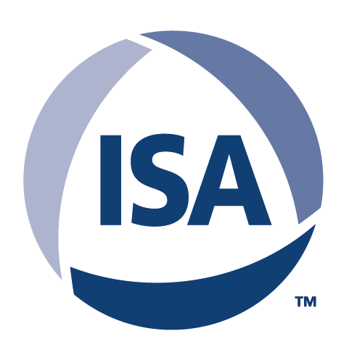

Brief Description

2013 ISA Water/Wastewater
and Automatic Controls Symposium
August 6, 2013 - August 8, 2013
Orlando | Florida | United States (USA)
Now in its eighth year, the annual symposium offers a unique opportunity for automation, instrumentation and SCADA (supervisory control and data acquisition) professionals in the water and wastewater sectors to share ideas, network and earn continuing education credits.
The 2013 ISA WWAC Symposium is a three-day event that focuses on the challenges associated with providing reliable, secure and cost-efficient automation for the world’s municipal water/wastewater infrastructure. The gathering features two full days of technical speakers/presentations, networking events, a poster session, and a supplier showcase. This year’s program also includes an optional tour of a local water treatment facility, and two optional short courses on SCADA cyber security and flow meter section/sizing.
Website: www.isawwsymposium.com
E-mail: graham.nasby@eramosa.com
Tel: 919-990-9418 (International Society of Automation)
Registration information
www.isawwsymposium.com/register/
Venue: Crowne Plaza Orlando-Universal Hotel

