2012 ISA Water/Wastewater and Automatic Controls Symposium  Aug 7-9, 2012 (Tues-Thurs)  Holiday Inn Castle Resort, Orlando, Florida, USA  www.isawwsymposium.com | 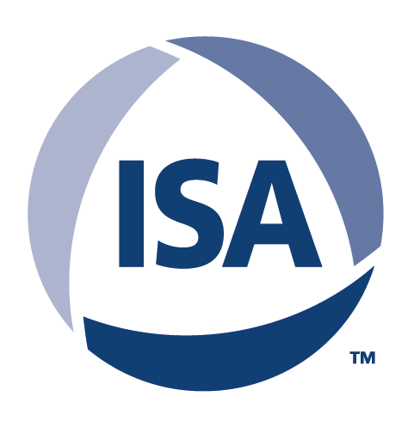

Presented by the Water and Wastewater Division of ISA, the WWAC Symposium helps professionals in the water and wastewater industries understand how automatic control applications affect processing and distribution of water treatment and provides an outstanding opportunity to gain valuable technical information and training.

This 3-day symposium is focused on the challenges associated with automation and instrumentation in the water and wastewater sectors. It features 2 full days of presentations (two speaking tracks), a tour of a local water/wastewater facility, a general reception, networking events, a poster session, and a supplier showcase.

The first day starts with symposium registration, a plant tour, and an optional full-day short course of Automation & SCADA System Security. The second day kicks off with a keynote speaker, followed by presentations on general water/wastewater topics such as instrumentation; system integration, automation, plant case studies, new technologies and process optimization/automation. The third day is focussed on leveraging automation technology with topics including SCADA, HMI, Human Factors, and Alarm Management. The Tues-Thurs timeslot has been picked so families can easily take their kids to Walt Disney Word, both during and before/after the symposium.

Watch the website for upcoming symposium announcements. This year’s invited speaker is Bill Hollifield who will be giving a talk on High Performance HMI design. Recognized SCADA security expert Bryan Singer will also presenting an invited about applying the ISA99 security standard. The symposium keynote speaker, and other notable speakers, will be announced shortly.

Online registration is now available at www.isawwsymposium.com. Early-bird registration for the 3-day symposium is $400 ($300 for ISA members). Students can register for $110. Rooms in the conference hotel are $79/night. The optional full-day training course Automation and SCADA System Security is $630 ($495 for ISA members, Note: ISA membership is only $100 per year). The symposium is targeted at anyone involved with automation, instrumentation, and/or control systems in the water/wastewater sector. Attendees typically range from plant operators, maintenance, and technical personnel to engineers, programmers and system integrators.

For more information about the 2012 ISA WWAC Symposium can be found at www.isawwsymposium.com or by contacting the general symposium chair Graham Nasby at graham.nasby@eramosa.com or the program committee chair Joe Provenzano at provenzano2@comcast.net

----

About the WWAC Symposium
Sponsored by the Water and Wastewater Division of ISA, the Water/Wastewater and Automatic Controls Symposium (WWAC Symposium) helps professionals in the water and wastewater industry understand how automatic control applications affect processing and distribution of water treatment and provide an outstanding opportunity to gain valuable technical information and training. It is “niche symposium” that offers a friendly atmosphere that caters specifically to the needs of automation professionals, technicians and engineers in the water/wastewater sector. Attendees range from plant operations, maintenance and engineering personnel to system integrators, design engineers and facility owners. The event has a traditional attendance of 75-100 attendees that come from across USA, as well as Canada and Mexico. The 2012 WWAC Symposium is being held in Orlando, Florida, USA on Aug 7-9, 2012. More information can be found at www.isawwsymposium.com
About the ISA
Founded in 1945, the International Society of Automation is a leading, global, nonprofit organization that is setting the standard for automation by helping over 30,000 worldwide members and other professionals solve difficult technical problems, while enhancing their leadership and personal career capabilities. Based in Research Triangle Park, North Carolina, ISA develops standards; certifies industry professionals; provides education and training; publishes books and technical articles; and hosts conferences and exhibitions for automation professionals. For more information see www.isa.org

